**Sort of a Ramayana: Setup, Walkthrough, and Notes**

**Setup:**

To install this quest copy the folder into whatever 'custom' folder you keep your scripts in. Place the 'ramayan.xml' file in the root folder of your ServUO/RunUO/JustUO/WhateverEmulator folder's directory. In-game use the [XmlLoad ramayan.xml command to create all the XMLSpawners. You can leave the xml file in the quest directory but then the [XmlLoad command gets very long adding the directory structure... Mine would be [XmlLoad scripts\customs\quests\ramayan\ramayan.xml. I put all my xml files in the emulator's root directory. This doc file and the Pic folder do not need to be copied into your game files, but it will not hurt if they are there.

If you are already using deides spawnable blue NPC scripts you will already have a BaseBlue.cs in your files somewhere. You will need the baseblue.cs file for the 'monkey army' to work (BaseBlue.cs was included in this quest package). If you are already using that script package simply delete one of the BaseBlue.cs scripts, it does not matter which one. I did no edits on that script. I take that back - on line 40 (BaseBlue.cs) I had to remark out a reference to "townsperson". Don't know what it is for but it gave an error.

There will be 6 XMLSpawners created.

1. Valmiki - original quest giver at the Tokuno Bank

2. General Hanuman - General of the 'monkey army' in Skara, near bank

3. Dungeon Entrance - Spawns Sita's Ring to teleport you to Uzeram's Dungeon. On Iver's Rounding island at (498, 2012, 2)

The next 3 are all in Uzeram's Dungeon.

4. Monkey Army - Spawns Hanuman's army, 5 helpers (blue NPCs).

5. Princess Sita - The captured princess.

6. Boss spawn - A sequential spawner - setup like a mini champ.

If you want them to spawn elsewhere, but want to keep all the other XML settings, you can just go into the xml file and edit the locations.

There is already a teleporter in Uzeram's Dungeon that takes you out to Old Haven. I changed the destination to New Haven (3501, 2583, 14). You may want to change yours as well.

**You will need to decorate for a dungeon entrance.** You need something visible for the quester to find. For the dungeon entrance the XMLSpawner will use the "trigger on carried" (looking for Hanuman's letter of introduction) to spawn Sita's Ring. I put a set of steps under the XML Spawner. If you do not know how to add them you can go to Despise Level 3 and "dupe" the steps. Change their property to 'movable' and place on the ground - make sure you change them back to unmovable, or they will decay. I also added some sparkle effects (duped from Uzeram's Dungeon). Try not to block the view of where the ring will spawn.

I have it set to only allow the quest done once. It is easy to change if you want. A simple true/false statement in the quest script.

**Quest is now setup.** You can quit reading if you want. I learned a lot while writing this quest so I will explain it below. It may turn into a book ha ha :)

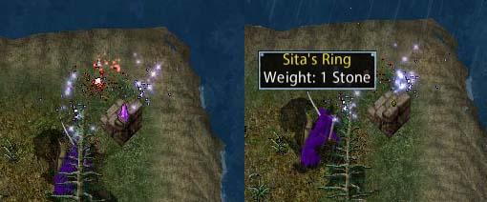

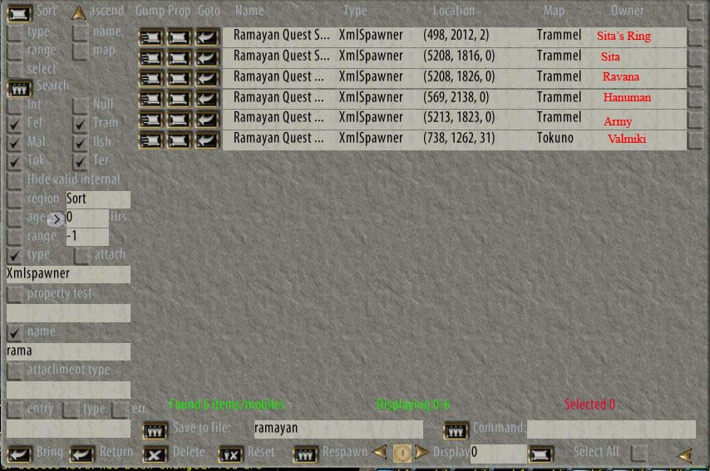

If you do an xml search your spawner will not have the red names on the spawners - I added those with Photoshop, for reference.

**Quest walk-thru:**

Talk to Valmiki to take the quest to rescue Princess Sita from the demon Ravana. This quest is a BaseQuest so it adds the quest tracker to your "quest" tab. The only thing in the quest log/objectives is to get Ravana's Earrings. Valmiki sends you to Skara Brae to find General Hanuman. Hanuman tells you where to find the dungeon entrance, and gives you a "letter of introduction" so his army will know he sent you. When you find the steps Sita's Ring will spawn. Double click the ring to be teleported to the dungeon.

Once in the dungeon proceed to the main room. The letter of introduction will trigger the spawner for the 'army'. They are 5 blue characters, so they fight on your side. They also talk a lot of crap.

The boss fight is a sequential spawn - like a mini champ. There should be 3 chaos daemons already there when you enter. After they die 5 daemons will spawn. Then 2 balrons. Then Ravana.

Take Ravana's head to Sita. When you give it to her she gives you Ravana's earrings. Mark them as a quest item (they turn orange). Take them back to Valmiki. Talk to him for your uber gear.

**Items:**

**Hanuman's letter of introduction** - Used to spawn Sita's Ring, and the Monkey Army. Self deletes in 6 hours.

**Sita's Ring** - spawns on the dungeon steps (ring is unmovable). Despawns in 5 minutes if not used. Double click it to teleport into dungeon. The ring deletes itself after teleporting you.

**Ravana's Head** - the only loot in Ravana's body. Make sure you loot it before using any [loot command (whatever command your shard uses).

**Ravana's Earrings** - Give Sita the head of Ravana and she will give you the earrings.

**Robes of Rama** - The quest reward. Double click it to raise and lower the hood. I made it a dyeable, simple straight 70's resist robe. I miss the good old days of just picking some armor out of you storage and fighting. So this gives you the resists now you can use your armor to get your other attributes you want. It is very easy to edit the properties on this robe if you want.

My reasoning - I like to make a more level playing field by making good loot easy to find. Otherwise new players will be playing 'catch up' forever. I am here to fight critters, not collect gear.

**Rambling:**

**Hanuman's letter of introduction** - Self deletes in 6 hours. I had to learn how to make an item self delete. It is easy to adjust in the script - lines 14 & 25. If you do not want it to self delete then remark out all timer references 14 & 15, lines 22-34, and line 38. If the script has been modified... I cannot guarantee those line numbers, but there are notations in the script. Because Sita's Ring and the Monkey Army spawn if you have the letter I made the letter self delete. I did not want them to keep respawning if someone stays in there. Although you can always go get another letter from Hanuman, whether you are on the quest or not - a weakness in the script, I admit. I am trying to figure out how to make Valmiki give an item to you, so you can trade it to Hanuman for the letter.

It seems that the 6 hours is actual server time, not real time. I had one in my pack and shut of the server for the night. When I turned it back on in the morning the letter was still there. I left the server on and it deleted. So the time does stop while the server is off, but resumes after you restart the server. In the instructions I found they said to put the timer in the serialize section to keep it working after a server restart. (Line 38). Without serializing it, they say, the timer will stop and the item will no longer delete. I have not tested this. (timer delete script tutorial http://www.runuo.com/community/threads/item-auto-self-delete-on-timer.537328/)

**Blue spawning NPCs**

The highlight, for me, of this quest is the use of helper NPCs. I had them at one time and moved computers... and forgot all about them. The monkey army script is based on the work originally released by deides on RunUO 3SEP11. (runuo.com/community/threads/need-new-players-add-them-with-my-custom-blues-2-1-svn.488880/). He has a baseblue script and a few different fighters. It was originally made to help with champ spawns on low population shards. I took one of his fighters and changed it around to fit my quest. I took away their mounts. Gave them hide armor, short spears, and tribal masks. They are human, not monkeys, but I am ok with that. His original package has a few fighters and a vendor to hire them from. A very cool script pack, you should check it out.

They fight on your side, and your AoE will not affect them. I tried using 'opposing group' critters to fight the demons - but they would turn on me during the fight. These blues are great. They will heal themselves, and resurrect you, if you are not a criminal.

The monkey army will despawn after 10 minutes. If you are still fighting they will respawn, as you still have Hanuman's letter. They are set to respawn in 2 seconds, so you will not be alone for long. Really though the whole fight should take less than 10 minutes. The blue NPCs can almost handle it alone. After the fight, and you leave, they despawn. I am trying to keep the quest from getting cluttered with spawn...

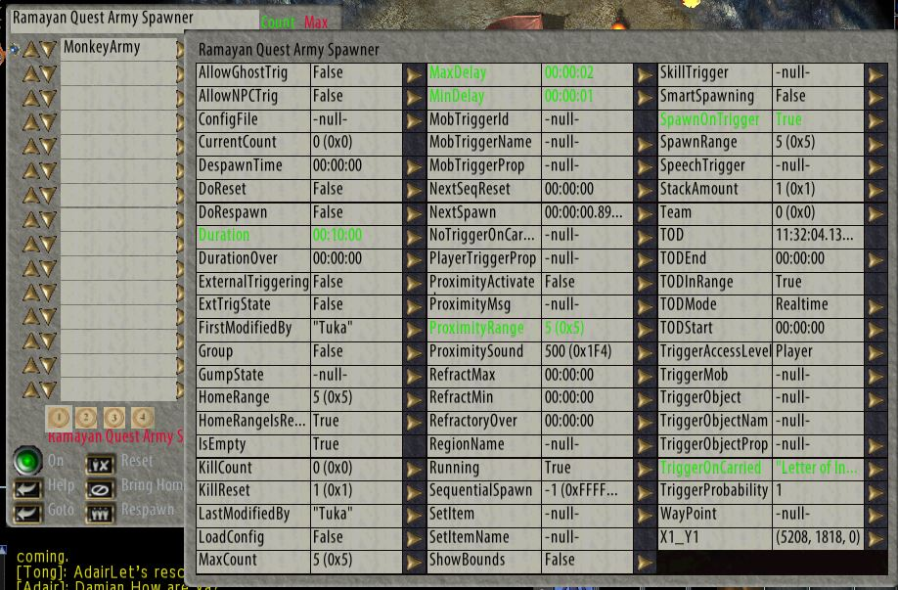

**Boss Fight - Sequential Spawner**

The sequential XMLSpawner gets a little weird every now and again. Sometimes you get duplicate groups before it progresses to the next group (that is kind of fun). Twice I have had it go through the entire spawn correctly and immediately the whole thing cycles again. (only done it twice and I cannot recreate it) It has also gotten stuck, a few times, and just not progressed. I added in some reset/to settings. So if the spawn is not killed in a certain amount of time the spawner will reset. I have it set for 60 minutes for each level, then resets back to the beginning (group 0). This way if you are fighting but having a hard time you should have time to get them killed. If the spawner gets 'stuck' or someone abandons the quest, it will reset in one hour and be ready for the next victim... quester. The timer seems to only function on server time, not real time (like Hanuman's letter). While I was testing it we lost power (5 minutes into a 10 minute despawn). After the power came back on the critters were still there. After about 5 minutes they despawned and the XMLSpawner refreshed to the beginning.

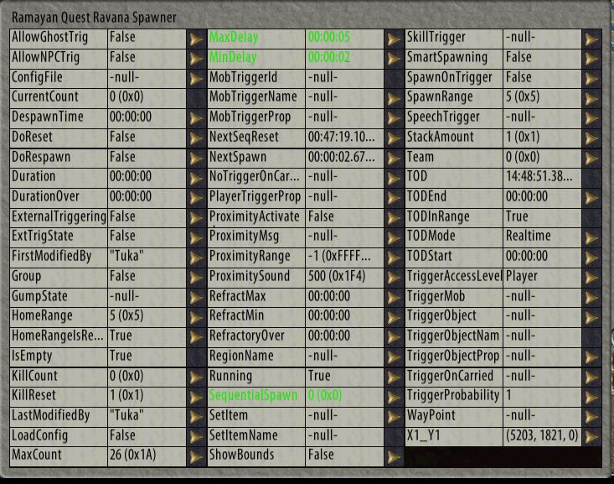

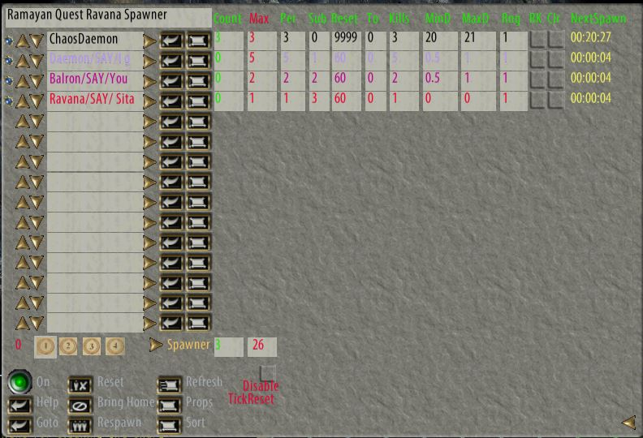

**Gizmo's Quest Creator**

I used Gizmo's Quest Creator for a lot of this quest. (<http://www.runuo.com/community/threads/uo-scripter-beta.92132/>) It has some issues because it is quite old. I found a couple problems: I was scripting Sita to be in a gilded dress, Gizmo coded "guilded dress". Also it mixed up SewerRats and sewerrats. Easy enough to fix, just something to be aware of. It is a nice program to learn about scripting quests. I used it to make the main quest, the letter of introduction, sita's ring, ravana's head & earrings. On the ring, Gizmo made the base item and I modified it to add some functionality. I added the teleport, and self delete feature. That was fun to learn. I won't go into a lot of detail on that since it is easy enough to see in the script. It is only 4 or 5 lines of code but took a couple hours to learn it. As I said it adds the quest to your quest tab, which is very cool. Now I know how to do that myself.

For Hanuman and Sita I just used the standard quests... the ones where you click on the NPC and there is a 'talk' option. I have no idea where they come from, I just edit the hell out of existing quests & gumps to make new quests. (Maybe they are from the XML quest maker?) So they progress you in the quest but are not actually part of the quest in the script. I need to study the Hag's & Matriarch quests to see how they work. There must be a way of incorporating more NPCs into the quest, but Gizmo does not handle it.

I hope the quest works out for you. If not, I hope you can modify it for whatever you need! Good questing. :)

Tukaram 18MAY2016